**Term 6 Bingo Cricket Challenge (BCC)**

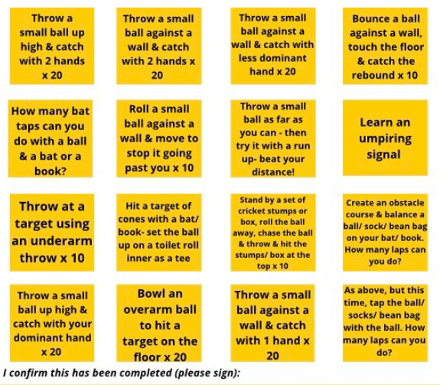At home, practice these skills and every time you complete one get it signed off by an adult. Once you have completed the bingo card bring it in to the Academy and give it to Mr Morton. At the end of the term, we will put all entries into a draw. The winner of the draw will receive a cricket set to enjoy over the summer. All entries to be handed in by Wednesday 14th July.

Many thanks to Lancashire Cricket FDN for creating the original bingo card.