ST. PAUL’S
C.E. PRIMARY ACADEMY


Healthy Eating Policy


Staff Member and Governor responsible for the policy | Lorna Watson
Date reviewed and shared with staff | January 2024
Date to be next reviewed by staff | January 2026
Signed by Chair of Governors:   | Signed by Head Teacher:    

Revision Number | Date Issued | Prepared by | Approved | Comments
1 | 31.1.24 | NH |  | Adding of becoming nut free for Feb 24

Introduction
Our vision for our Trust is we exist to:

Help every child achieve their God-given potential

Our aims are clear. We aim to be a Trust in which:

Developing the whole child means pupils achieve and maximise their potential
Continued development of staff is valued and improves education for young people
All schools are improving and perform above national expectations
The distinct Christian identity of each academy develops and is celebrated

Our work as a Trust is underpinned by shared values. They are taken from the Church of England’s vision for Education and guide the work of Trust Centre team. They are:

Aspiration
I can do all things through Christ who strengthens me
(Philippians 4 vs 13).

Wisdom
Listen to advice and accept discipline, and at the end you will be counted among the wise
(Proverbs 19 vs 20)

Respect
So in everything do to others what you would have them do to you
(Matthew 7 vs 12)

Our vision of helping every child achieve their God-given potential is aligned with the Church of England’s vision for education and is underpinned by the Bible verse from John: I have come that they may have life, and have it to the full.

School Vision

“To create a Christian school which ignites a thirst for knowledge in every individual, where curiosity and talent are cultivated, and children are empowered to channel their love of learning to achieve their God-given potential.”

Our Mission
Within In a Christian environment, we aim to provide a beacon of light to guide children on their journey through life, equipping them with the values which will allow them to flourish and lay the foundations for their future development. ​
Every adult is committed to being inspirational; sharing their knowledge, interest and passions; creating life-long learners who are confident exploring, navigating and developing their understanding of the world around them.
Our Values
At St Paul’s, our values permeate all areas of school life and are reflected by the Academy’s Christian Values:

To persevere with everything, we do.
To show respect for each other and the world around us.
To forgive others when they hurt us.
To always be honest and tell the truth.
To serve others.
Give thanks to God for all he does for us.
Policy for Healthy Eating

Introduction

We value all members of the school community and seek to promote the health and well-being of all members as part of being an enjoyable place to work and learn. We recognise that food and nutrition form an important aspect of our health and well-being and thus contribute to all being able to learn effectively. We recognise that food and drink play an important role in our different cultures and for all of our emotional and social well-being and are committed to communicating consistent messages across the school.

As of 19th February 2024, we are now a fully nut free school to protect pupils and staff that suffer from nut allergies.

This policy should be read alongside the school’s policies for: Health & Safety, First Aid, Admin of Medicines, PSHE, Wellbeing and Mental Health, PE – Physical Activity and Design Technology.

The purpose of this policy is to inform all members of the school community, to implement systems and structures and to be consistent about the food and drink provision at our school.

The scope of this policy encompasses all food and drink consumed on the school site and as part of a school activity. It aims to promote the Balance of Good Health and to promote sustainability through reduced packaging, responsible recycling and disposal of the waste produced by food and drink.

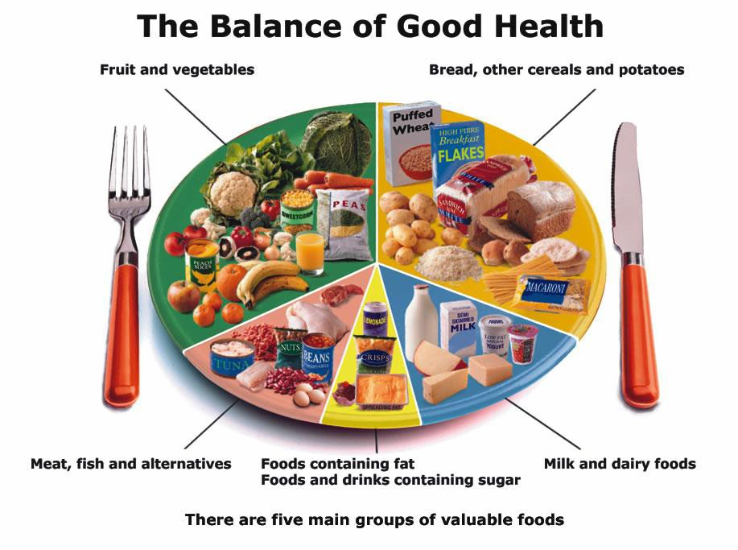
A healthy diet is defined as one where there is a balance of food and drink which provides the nutrients required in the right amounts.

Aims and Objectives

Our aim is for all aspects of school life to promote the health and wellbeing of all members of the school community, including food and nutrition, as part of our commitment to being a Healthy School.

Objectives

- To set out a consistent approach to food and drink provision throughout the school day.
- That all our pupils learn about food and drink as part of a curriculum that supports health and wellbeing.
- To provide high quality school meals to our pupils, within the resources available.
- To provide suitable social settings for pupils and staff to consume food and drink.
- To work in partnership with parents and carers.
- To promote being a NUT FREE environment for the safety of our pupils and staff.

The Curriculum

Teaching about food and drink forms part of the curriculum.

  - In EYFS, KS1 and KS2, there are a number of opportunities for pupils to develop knowledge and understanding of health, including healthy eating patterns and practical skills that are needed to understand where food comes from such as shopping, preparing and cooking food.
  - English provides children with the opportunity to explore poetry, persuasion, argument and narrative work using food and food related issues as a stimulus, eg writing to a company to persuade them to use non-GM foods in children's food and drink etc.
  - Maths can offer the possibility of understanding nutrition labelling, calculating quantities for recipes, weighing and measuring ingredients.
  - Science provides an opportunity to learn about the types of food available, their nutritional composition, digestion and the function of different nutrients in contributing to health and how the body responds to exercise.
  - RE provides the opportunity to discuss the role of certain foods in the major religions of the world. Children experience different foods associated with religious festivals.
  - Computing can afford pupils the opportunity to research food issues using the internet and other electronic resources. Pupils design packaging and adverts to promote healthy food choices.
  - Food Technology as part of DT provides the opportunity to learn about where food comes from and apply healthy eating messages through practical work with food, including preparation and cooking.
  - PSHE encourages young people to take responsibility for their own health and wellbeing, teaches them how to develop a healthy lifestyle and addresses issues such as body image. Pupils are able to discuss issues of interest to young people, eg advertising and sustainable development.
  - Geography provides a focus on the natural world and changing environment, offering the chance to consider the impact our consumer choices have on people across the world who rely on growing food as their source of income.
  - History provides insight into changes in diet and food over time.
  - Physical Education provides pupils with the opportunity to develop physically and to understand the practical impact of sport, exercise and other physical activity such as dance and walking.
  - School visits provide pupils with activities to enhance their physical development e.g. to activity centres.
  - Out of hours learning includes gardening clubs from time to time.

Wherever possible, practical and active teaching and learning opportunities will be provided for pupils, in particular to develop skills in the preparation of food, in the analysis of food and in maintaining personal health. Lessons which use the creative learning opportunities of food and drink will also be developed across the curriculum.

The whole school nature of learning about food and drink is reinforced through assemblies and in celebrations. When visitors, such as parents or specialist cooks, are involved in lessons about food and drink, they will work in accordance with this policy and always with a member of the teaching staff present.

Food and Drink Provision

School meals are provided by Chartwells on-site and follow the nutritional guidelines set out by the Department for Education (DfE). The implementation of national nutritional standards and information about the style of service and menu content are identified in the catering contract.

Steps are taken to excite and motivate pupils to try new foods, and also to involve and consult with pupils and parents / carers about school meals. These include theme days and tasting sessions, Healthy Eating Weeks and all other opportunities that arise to continually raise the profile of healthy eating in school. Menus are displayed and available to parents. We are committed to non-discriminatory procedures to ensure all pupils who are eligible for free school meals take up their entitlement.

The importance of pupils and staff having enough time to eat and digest lunch is considered when planning the school day.

Chartwell’s menus are completely nut free and they are made aware of other allergies children may have to insure all food is safe to consume.

Breakfast Club
Breakfast Club operates on a daily basis, in the school, for all children from age 4. The food offered is healthy and is consistent with a healthy diet. We provide toast, bagels, bread, low fat spread, fruit jam, marmite, yoghurt, low salt/low sugar fortified cereals, yoghurts and slices of fresh fruit. Children choose from water, orange juice and apple juice to drink.

After School Club (SPLASH)

SPLASH operates on a daily basis, in the school, for all children from age 4. The food offered is healthy and is supportive of a healthy diet in line with The Children’s Food Trust – Eat Better Do Better.

Snack
All EYFS and KS1 classes receive a morning break-time snack of washed vegetables or fruit which is shared in a family setting for all class members. In EYFS and Y1 children are given responsibility for passing the fruit to others and for helping to clear away. This Government initiative means that we can provide all infants with free fruit and vegetables during the day.
Snacks provided for pupils or brought from home should be low in saturated fat, sugar and salt, preferably fruit or vegetables. Snacks from home that contain nuts will be sent home unopened with a note to parents.

Special dietary needs

Parents / carers are expected to inform schools of allergies and other diet related medical conditions. The school will support pupils with special dietary needs during the school day.

Celebrations, treats and rewards

The school recognises that food is often an important element of celebrations and will ensure that healthy options are available. Parents may only provide cakes and sweets for birthday celebrations. The school will use non-food based rewards except for end of term Golden Galleon house winners celebrations where a selection of nut free biscuits and juices will be given to children. We will also provide snacks suitable for vegans and in the summer term, fruit-based ice lollies.
Staff that also bring in treats for birthdays, fundraising and end of term will also follow the nut free guidance.

Drinks

The school recognises the contribution that the consumption of sufficient water makes to learning, positive behaviour and health. The school will meet its legal requirement to make clean, palatable water available to all pupils and staff throughout the school day. Parents / carers are asked to provide an appropriate container for drinking water. It is the responsibility of the parent/carer/child to ensure that their bottle is clean and that water is changed daily.

Dining Environment

The school aims that all eating environments are welcoming and encourage the positive social interaction of pupils and staff. The school will specify areas for eating meals and will ensure all such areas have easy access to drinking water and facilities to dispose of/ recycle waste.

Partnership with parents

The school will work actively with parents / carers about food and diet. This will include:
    - Menu consultation and tasting of school dinners.
    - Information about a balanced and healthy packed lunch.
    - School events.
    - Information about becoming nut free with foods that are now not permitted in lunchboxes.

All events will aim to take place consistently with this policy.

Professional development

All school staff and governors will have access to opportunities for CPD to support the implementation of this policy. Groups of staff will have particular CPD needs, which will be addressed, for example for MDSAs, to encourage consistent implementation at lunchtime, and teachers of DT around Food Technology. Food Hygiene certificates are required for all DT based lessons and cooking classes.

Health and Safety

All food preparation will adhere to the school’s health and safety policy and be carried out according to good food hygiene and preparation standards. Health and safety remains the responsibility of all staff. Wherever possible, food preparation will be carried out in designated areas in the school and an equipment inventory for food technology will be maintained and audited by the DT coordinator.
The school’s risk assessment procedures will include consideration of food hygiene. Parents/ carers should notify the school in writing of any special medical dietary needs and the school will work in the best interests of the child.

Implementation

The implementation of the Food Policy is the responsibility of the PSHE subject leader, who will consider aspects of healthy eating as part of developments in the school. Class Teachers are responsible for the co-ordination of the curriculum in relation to food, drink and nutrition. Steps will be taken to consult with pupils, including via the school council, about food and drink provision at school.

Governors will monitor the food policy, including the provision of school meals. They will include consideration of the food and drink available as part of their visits to school. Opportunities will be taken to inform parents / carers about the policy, and to respond to comments.

Monitoring and Review

The monitoring of this policy will be the responsibility of the PSHE subject leader. Progress with healthy eating as part of health and wellbeing and Healthy Schools developments will be monitored as part of the Academy Development Plan. Individual subject curriculum policies will set out the learning elements which relate to food and drink and these will be monitored as part of regular subject monitoring. This policy will be subject to a formal review every three years or sooner if significant changes occur.

Healthy Eating- Useful websites

https://www.foodafactoflife.org.uk/
This website is an excellent resource for providing lessons across the school for teaching cooking and knowledge of healthy food options.

The Essential Guide

8 Key Themes that run through the resource: ‘Whole School Food Policy’, Healthier Breakfast Clubs, Healthier Tuck Shops, Water Provision, Healthier Vending, Healthier Lunchboxes, Dining Room Environment, Healthier Cookery Clubs and Growing Clubs.

www.sustainweb.org
This is the web site for the charity ‘Sustain, The Alliance for Better Food and Farming’. This site has access to the Grab5! Pack – a healthy eating tool for KS2 pupils.
There are many useful sections including curriculum links, model Whole School Food Policy. All or parts of the pack are downloadable.
Another interesting and informative paper called ‘Changing Diets, Changing Minds: how food affects mental health and behaviour is published on this site.

www.bhf.org.uk
Resources and information about a healthy diet and exercise for all ages. Click the navigation bar for links to teaching resources; cbhf.net (for under 11s) yheart.net (for over 11s); Food4Thought website. Some of the resources are free.

www.phunkyfoods.co.uk
The PhunkyFoods Programme aims to help early years settings and primary schools to deliver a whole-settings approach to healthy lifestyles and to engage with all pupils, and their families, in promoting tangible health behaviour changes in a fun, lively and positive manner.

www.anaphylaxis.org.uk/education/safer-schools-programme/
Anaphylaxis for schools provides training, resources and insight to being Allergy wise in schools and early years settings. There are handy class packs to help everyone understand their role to keeping everyone safe.

