Let your light shine

St Paul’s CE Academy





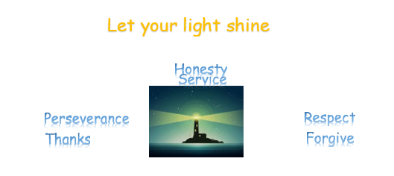

Positive Behaviour Policy

|  |  |
| --- | --- |
| Date reviewed and shared with staff | September 2024 |
| Date to next be reviewed by staff | September 2025 |

**St Paul’s CE Academy Positive Behaviour Policy**

**School Vision**

“To create a Christian school which **ignites a thirst for knowledge**in every individual, **where curiosity and talent are cultivated**, and children are **empowered** to channel their **love of learning** to achieve their God-given potential.”

At St Paul’s C.E. Academy we are very proud to be a culturally diverse and fully inclusive school that is committed to ensuring that we aspire to and achieve. We believe that prosocial behaviour is essential for effective teaching and learning.

We aim to:

* Provide a happy, healthy and safe environment where every child is valued and inspired to achieve and exceed their potential.
* Provide every chance to strengthen positive relationships with our families and the wider community.
* Provide an enriched curriculum every day which will develop every child’s self-confidence, resilience and passion for lifelong learning.
* Have high expectations and aspirations for the achievement of every child, providing them with high quality teaching and personalised learning opportunities every day.
* Respect the religious and cultural traditions of every child and in doing so, celebrate our British values and the diversity reflected within our school community.

Let your light Shine

Our Academy Christian values are:

To **persevere with everything, we do.**

To show **respect**for each other and the world around us.

To **forgive**others when they hurt us.

To always be **honest**and tell the truth.

To **serve**others.

Give **thanks**to God for all he does for us.

##### AIMS

* For the Positive Behaviour Policy to be supported and followed by the whole school community – parents/carers, teachers, pupils and governors.
* To foster a caring, nurturing atmosphere, in which teaching and learning can take place in a safe and happy environment.
* To teach moral values and attitudes to promote responsible behaviour, self-discipline, self-respect and respect for other people and property.
* To celebrate prosocial behaviour, by providing a range of rewards for pupils of all ages and abilities.
* To make clear to pupils the distinction between difficult and dangerous behavior and the consequences that will follow.
* To resolve behavioural problems by adopting a restorative approach.
* To ensure consistency through the use of the Behaviour Ladder across the school.
* Whilst this **Positive Behaviour Policy** applies to all pupils, careful consideration must be taken of individual pupil’s needs e.g. those with **Autistic Spectrum Disorders, Emotional Behaviour Difficulties, Attention Deficit Disorders, Behaviour Support Plans and Pastoral Support Plans or other unknown/unmet needs.**

##### The Governing Body should:

* Promote and monitor the implementation of this policy
* Promote whole school adherence to the practices within it
* Ensure equality of delivery to individuals and groups through monitoring exclusions.

##### Staff should:

* Provide positive role models at all times
* Follow procedures in this policy
* Establish and maintain clear and consistent expectations and boundaries
* Discuss with pupils when and how they could have made more positive choices when they have responded to a situation
* Encourage self-motivation and independence
* Promote self-esteem and self-respect in pupils
* Work in partnership with parents/carers to support pupils to develop positive behaviour and celebrate their pupils efforts and achievements
* Maintain well organised learning environments and appropriately challenging or supportive learning opportunities
* Respect pupils and listen to their views without discrimination.
* Ensure parents are verbally informed of all level 3 incidents by the class teacher, or level 4 incidents by a member of the Senior Leadership Team. This conversation is recorded on the pupil’s file.

##### Parents and Carers should:

* Ensure their children attend school regularly and punctually
* Support the school in its strategies for managing behaviour
* Inform the school (class teacher in the first instance) of any factors which may influence a pupil’s behaviour
* Support their child(ren) in learning to resolve difficulties in a positive manner

##### Pupils should:

* Arrive on time every day ready to learn
* Tell an adult if they see something that they know is wrong
* Take responsibility for the choices they make
* Try to communicate their feelings to a trusted adult

*We will not accept discriminatory behaviour of any kind from any party. All pupils and adults have a right to be respected and the responsibility to give respect to others including those with Special Educational Needs. This is in accordance with the 2010 Equality Act.*

*See also our SEND, Equal Opportunities, Anti- Bullying & Equalities Duty policies for further details of this.*

**The EYFS Behaviour Procedures**

**Positive behaviour reinforcements are used at St Paul’s**

Early Years staff will encourage and support children to develop a sense of right and wrong by helping children to cooperate at school. Staff will always try to explain, reason with and calm the child. Children are always encouraged to apologise and reflect on antisocial behaviour. Any incidents will be brought to the parent/carers attention and discussed with them.

Staff will be aware of the age and stage of development of the child and of any cultural, linguistic or particular needs. Physical intervention, i.e. holding, will be used only to prevent injury to the child, other children or an adult or serious damage to the property.

 **Start Routine** for encouraging children to cooperate with instructions. The Start Routine requires children to follow an instruction after two requests. Children are rewarded with praise.

GIVE INSTRUCTIONS

CHILD DOES NOT DO AS ASKED

LOGICAL CONSEQUENCE/ TIME OUT

CHILD DOES AS ASKED

WAIT FOR 5 SECONDS

WAIT FOR 5 SECONDS

PRAISE

REPEAT INSTRUCTION

CHILD DOES AS ASKED

CHILD DOES NOT DO AS ASKED

PRAISE

The **Stop Routine** is used by EYFS for the following behaviour, which is considered antisocial at St Paul’s, whether towards an adult or another child:

* Biting;
* Kicking;
* Hitting;
* Pinching;
* Inappropriate language;
* Throwing/breaking toys/equipment/furniture.

GIVE INSTRUCTIONS

WAIT FOR 5 SECONDS

CHILD DOES NOT DO AS ASKED

CHILD DOES AS ASKED

PRAISE FOR DOING AS REQUESTED

LOGICAL CONSEQUENCE/ TIME OUT

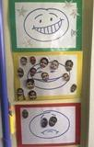

Examples of logical consequences are as follows:

* Time out in class (with timer) to allow child to calm down and reset;
* Time out in a different class (with another adult)to allow child to calm down;
* Apologising;
* A conversation with the child;
* A conversation with parents.

On display in the EYFS, is a simplified version of the Behaviour Ladder found in the rest of the school- Outstanding; Ready to Learn; Warning, Teacher’s Choice

(see below).

##### Promoting Positive Behaviour

##### House Point System

##### 

Every pupil in school is allocated a House which they will be in for their life at St Paul’s. The houses are named after courageous advocates – Attenborough, Baird, Malala and Teresa.

Dojos are given to pupils for following the Academy’s Christian Values as well as for behaviour, work and for working towards being the best they can be. Pupils can be given dojos or house points at any time of the school day by any member of school staff. When a child has earnt ten dojos, they are awarded a house point.

House coins are collected every Friday lunch time, they are weighed and added to a collective weekly total. Red coins are given to pupils for following a specific behaviour focus (these change every two weeks). Silver coins are also presented to pupils from MDSAs, extended schools staff and site managers. Gold coins are awarded by SLT for improved or outstanding attitude, behaviour and work ethos.

Each week during Golden Galleon assembly, which all staff are expected to attend, house points will be announced. At the end of each term/year the house with the highest number of points will have an afternoon house celebration.



##### House Captain:

Each house will elect a House Captain from Year six pupils, selected at the end of Year 5. Each campaigning House Captain will draw up a manifesto and will be elected by the Year 5 cohort at the end of the summer term. The House Captain will have the following responsibilities:

* Be a leader for the house;
* Be an exemplary ambassador;
* Be a good behaviour role model for the whole house and school;
* Represent the house when it comes to prizes and decision making about the end of term/year reward;
* Organise inter-house events;
* Leading Assemblies and Sports days.

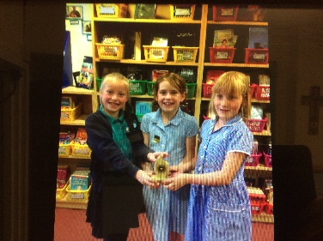

##### Golden Galleon Certificates and Golden Tickets

Each week, teachers will nominate five pupils in their class to receive a Golden certificate as well as a Golden ticket during golden Galleon Assembly – the 5 categories are: English Achievement; Maths Achievement; Outstanding Behaviour; Presentation; Let Your Light Shine Award.

**Incentives and Rewards- Golden Tickets and Dojos**

##### These must be promoted by the whole school community.

##### Children are awarded Dojos for- outstanding or improved behaviour; working hard; improved or improving resilience; being on task; persistence, amongst other things.

##### Golden Tickets will be pulled out of the Treasure Chest in two separate assemblies, where the children will win a prize in the final term’s assembly.

The following incentives and rewards for achievement apply:

* House points awarded for following the Academy’s Christian Values;
* Dojo points;
* 10 Dojo points = 1 house point;
* 50 Dojos = 1 Golden Ticket- which is entered into a Year 1, 2, 3 or Year 4, 5, 6 ‘treasure chest’;
* Golden Galleon celebration Assembly;
* Wining house party at the term;
* 8 Golden tickets and certificates pulled out of the Golden chest termly;
* End of year reward.

##### Promoting Positive Behaviour

Support for pupils who do not or cannot adhere to the behavior policy begin when a pupil has been given a chance to correct their behaviour and they have not done so. The behaviour levels and warning system listed below should be started afresh each morning, after break and afternoon. All members of staff working with groups or individuals must apply the behaviour policy.

##### Positive Behaviour Ladder

Each classroom has a Positive Behaviour Ladder with 5 steps. At the beginning of each morning, after break and afternoon sessions pupils’ names will be displayed on the yellow step. Pupils can be moved up the ladder for prosocial behaviour and down the ladder for antisocial behaviour. Identified pupils will be spoken to discretely (rather than visually on the behavior ladder. These pupils will be identified by the class teacher alongside the SENCO or behavior lead.

##### Behaviour Ladder, Consequences and Procedures:

|  |  |  |
| --- | --- | --- |
|  | Classroom | Playground |
|  | For excellent behaviour, work and demonstrating the St Paul’s Christian Values | |
|  |  | |
|  | WORKING HARD- Children move to this when their behaviour for learning is good | |
|  | **All children begin on Yellow** | |
|  |  |  |
| Level 1 | Informal Warning Level | Informal Warning Level |
| Action Required | * Clear Verbal Warning (done discretely) * Use refocusing, redirecting, use language of choice‟ or a reminder * Move down to Pink on Ladder | * A verbal warning will be given in the first instance of antisocial behaviour |
|  |  |  |
| Level 2 | Formal Warning Level | Formal Warning Level (In Playground Time Out) |
| Action Required | * First Formal warning * Move down to Orange on Ladder | * Formal warning given * Child sent to allocated area for 5 minutes away from other children to reflect on their behaviour |
|  |  |  |
| Level 3 | Sanction and External Class Time Out | |
| Action Required | * Second warning cross written on the board * Up to 10 minute reflection at lunch time * Up to 40 minute reflection at lunch time * Completes any work given * Move down to Blue on Ladder | If antisocial behaviour persists a reflection slip should be issued from the playground and the pupil sent to the Pier or the Behaviour Support Lead should be called for if the child refuses to move off the playground  Reflection 1: 10 minute ; Reflection 2: rest of lunch  MDSA to radio Pier |

|  |  |  |
| --- | --- | --- |
|  | * Lunch time consequence (educational and protective) * Restorative conversation * Differentiated break * Skills club * Time to catch up on learning * Parents/carers should be informed verbally by the class teacher or by the Behaviour Support when they have received a ‘Reflection 2’ consequence or 5 lots of ‘Reflection 1’ lunchtime consequences | |
|  | * The child is moved back to Yellow after a consequence is completed. * The child is moved back to Yellow at the beginning of a morning, after break or afternoon session   (although incomplete consequences still need to be completed) | |
|  |  |  |
| Level 4 | If there are further issues before the consequence is completed, then it becomes a level 4 incident. Behaviour Support Lead is notified. The following behaviours bypass Level 1 to 3 (although are not limited to these examples). Suspensions or exclusions may also be considered.   * Physically harming another (whether pupil or adult) * Repeatedly swearing and using abusive language towards others * Deliberately damaging/stealing school property * Refusal to follow reasonable requests with implications for health and safety of the pupil or others e.g. leaving the school premises without permission * Persistent disruptive behaviour * Threatening others/ threatening with and /or using a weapon * Bringing a weapon on the premises * Comments that discriminate along the lines of race, gender, religion, sexual orientation and ability. * Racism incidents | |
| Racist  incidents | * One incident will result in a morning or afternoon internal suspension. * Two incidents will result in a whole day internal suspension. * Three incidents or more will result in one or more suspensions.. | |

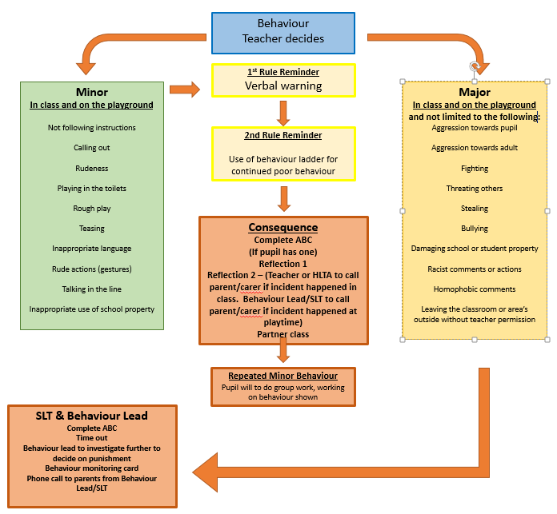

**NOTE:** **Years 1 and 2** for a ‘Reflection 2’ consequence, the child will be spend time in the Harbour developing their social skills.

**Alternative Behaviour Pathway**

* An alternative pathway responds to behaviour of particular SEND children/children with unknown needs to support them with their individual needs.
* The child concerned will be seen on the day the behaviour has occurred.
* Specific children will receive a **‘restorative work’ slip** – not a lunchtime reflection slip.
* Specific children will be seen by the SENCO or the Behaviour Lead

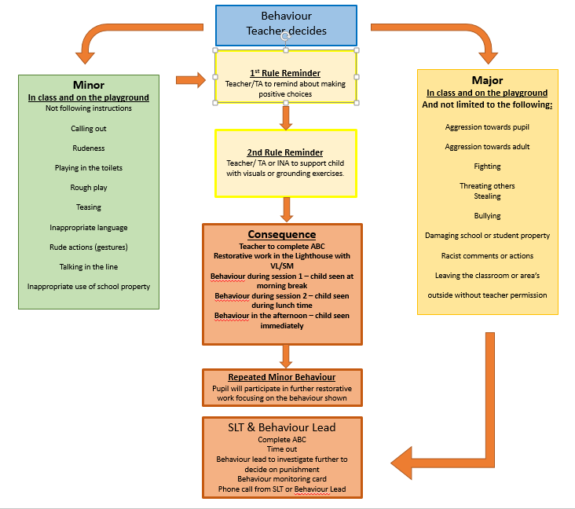

**Reflection Session Chart** The following are examples of reasons a child will have a Reflection Session

**Key Stage 2**

Notes:

* If a pupil refuses to go to another class or to attend the Harbour, support should be sought from the **Learning Behaviour Lead**;
* Refer to procedures as set out in the **Academy’s Anti-Bullying Policy** for all allegations of bullying;
* **Level 4:** These behaviours are deemed serious enough to bypass the procedures mentioned previously and will be dealt with by a member of the **Learning Behaviour Lead** or the **Senior Leadership Team**. They can lead to suspension, depending on severity and circumstances.

|  |  |  |
| --- | --- | --- |
| **Reflection 1 consequence**  (upto 10 minutes) | **Reflection 2 consequence**  ( up to 40 minutes lunchtime) | **Partner class** |
| * Continuous disruption in class * Not doing ask asked * Defiance * Disrupting learning | * Fighting * Stealing * Rudeness to adults * Continuing to disrupt learning * Inappropriate behaviour/language * Throwing equipment in class | * Disruptive behaviour * To complete work * Time out needed |

**In class**

**During playtime/lunchtime**

|  |  |  |
| --- | --- | --- |
| **Reflection 1 consequence**  (up to 10 minutes) | **Reflection 2 consequence**  (up to the whole of lunch time) | **Learning Behaviour lead/SLT** |
| * Not doing as asked * Deliberately/continually spoiling other children’s games * Deliberately damaging equipment * Rudeness to an adult | * Fighting/ aggression * Inappropriate behaviour/language * Swearing at other children **confirmed after investigation** (dependent on the severity of the swearing) * Swearing at an adult * Or any of the above behaviours admitted to by the child. | * Refusal * **Racist, discriminatory remarks and homophobic** language **confirmed after investigation** |

**Notes:**

* **The Learning Behaviour Lead** will be called for, if a child refuses to leave the playground;
* If a disagreement has occurred between children and a MDSA cannot resolve the incident, the children involved are to be sent to the Pier where the SLT member on duty will deal with the situation. This may also involve looking at CCTV.

##### Level 3 and 4

* Pupils who get to **level 3** will be managed by the class teacher and phase leader where needed. **Level 3** incidents must be recorded on a consequence slip. Parents/carers will be informed verbally by a member of staff.
* Pupils who get to **level 4** will be sent to **Learning Behaviour Lead** or a member of the **Senior Leadership Team** who will investigate the incident and take appropriate action. The incident, including any action taken, will be recorded on Arbor. Parents/carers will be notified.
* **Suspensions and exclusions may be issued.**

**CONSEQUENCE PROCEDURES**

Pupils at **Level 3** will have a lunchtime reflection session following the incident for either 10 minutes or up to the whole of lunchtime depending on the behaviour.

The member of **SLT** on duty will be responsible for restorative discussion and/or educational consequences. The consequence slips will then be given to the **Behaviour Lead** **and the Receptionist** to record both O:\Behaviour and on Arbor respectively.

**The Assistant Headteacher responsible for behaviour** and the **Behaviour Lead** will monitor consequences on a weekly basis.

* Consequence slips will be given to the Behaviour Lead to record on the ‘reflection session’ tracker. The Receptionist will then record the reflection session on Arbor.
* In a single Term.
  + If a pupil incurs a Reflection session 2 in class the **class teacher/HLTA** will contact the parents.
  + If a pupil receives a Reflection session 2 on the playground, either the **Behaviour lead** or **SLT** will be called to investigate the incident. **SLT** or the **Behaviour** lead will notify the parent via a phone call as soon as possible.
  + Parents will be invited in to speak to the class teacher if a pupil’s behaviour begins to deteriorate.
  + 3 lots of Reflection session 2 will trigger a letter to the parent inviting them in to meet with the **Class Teacher**. The Behaviour Lead will inform the class teacher to contact the parent to arrange a meeting.
  + 3 further lots of Reflection session 2 will trigger a further letter to the parent inviting them in to meet with the **class teacher** and **Assistant Head** to draw up a Behaviour Support Plan. The Behaviour Lead will inform the class teacher to contact the parent to arrange a meeting.
  + The Behaviour Support plan will be reviewed and discussed with the child and parents/carers.
  + **5 lots of Reflection session 1** will trigger a letter to the parent inviting them in to meet with the **Class Teacher**. The Behaviour Lead will inform the class teacher to contact the parent to arrange a meeting.
  + 5 further lots of Reflection session 1 will trigger a further letter to the parent inviting them in to meet with the class teacher and **Assistant Head** to draw up a Behaviour Support Plan. The Behaviour lead will inform the class teacher to contact the parent to arrange a meeting.
* The severity of the incident will override the above straight to **Assistant Heads** or **SLT**.
* Teachers will be notified of children with identified SENd needs who will be provided with an alternative behaviour support plan which will be recorded on their ANP.

##### Reflection Session- Pier

Pupils receiving a lunchtime Reflection Session will have a restorative conversation, given the opportunity to complete missed learning or be provided with time to reflect on their choices.

**Reflection Session time table**

|  |  |
| --- | --- |
| **Day** | **SLT** |
| Monday | Mr Glenn |
| Tuesday | Miss Watson |
| Wednesday | Mrs Hodgson |
| Thursday | Mr Trimmings |
| Friday | Miss Kiniari |

##### Time Out:

In Class Time Outs (level 2) are completed within the child’s normal classroom. An External Time Out (level 3) time out will apply for level 3 or level 4 behaviour.

The pupil will complete their set work, provided by the class teacher, in another classroom.

Parents/carers are informed as soon as possible either by a telephone conversation or a one-to-one conversation with the parent.

##### Differentiated breaks:

* The Behaviour lead or Senior Leadership Team will contact the parents/carers as soon as possible, ideally on the same day.
* The pupil will be restricted from accessing the playground or a specific activity for a fixed number of breaks and lunch times depending on the incident, decided by a member of **Senior Leadership Team**.

##### Internal Exclusions:

* A member of the **Senior Leadership Team or the Behaviour Lead** will contact the parents/carers on the same day, if possible;
* All paper work will be completed by the **Behaviour Lead;**
* The pupil will spend a fixed amount of time within school, but away from their class. This will also include break and lunch times. This will be recorded by the **Behaviour Lead.**

##### Fixed Term Suspension:

* The school will contact the parents/carers as soon as possible.
* It is expected that parents will collect their children as soon as possible on the day of the issuing of a suspension. If this is not possible, then the child will kept away from their class, and the suspension will be postponed to commence the next day.
* A letter will be sent home within 24 hours outlining the reason(s) for the suspension.
* Work will be provided by the class teacher for the length of the suspension. It is expected that this is returned to school
* Parents are expected to meet with the **CoHeadteachers or** **SENCo** on the day that the pupil returns to school for a reintegration meeting.

Only a **Headteacher** or **Acting Head Teacher** can suspend a pupil from school.

If a fixed term suspension of more than 5 days is deemed, then appropriate full time provision will be sought by the school.

##### External Agency Support

It may be felt that when a pupil has a behavior support plan, but it has had limited impact on the child’s behaviour, other agencies including **Education Support Behaviour and Attendance Service (ESBAS**) will be contacted to ensure that specific professional expertise is accessed in order to meet the needs of the pupil.

##### Alternative SENd Pathway

The alternative pathway for SEN children adopts a timeout/reflection approach for all children. These children have a consequence immediately. They will have restorative work with a member of staff in the Harbour.

**Nursery**

All children’s wellbeing, mental health, welfare/safety and dignity is paramount to us. Our aim is to empower children to be in control of themselves, using their own autonomy. Children of nursery age are learning, developing and managing their emotions the best they can. Our job is harness this, guide and teach, getting children ready for their transition to school and beyond.

In nursery we adopt the best practice of the Therapeutic Thinking approach. Therapeutic Thinking is a philosophy. It focuses on how all children are to be supported, particularly in terms of their emotional wellbeing and mental health; it also helps to develop an understanding of how to respond to those who may be communicating through concerning behaviours. Particularly as children’s behaviour is a form of communication and is always telling us something. The Therapeutic Thinking approach has an ethos which is characterised by an inclusive culture, based on training and information that is underpinned by best practice, policy and plans.

Therapeutic Thinking builds on the relationships between practitioners and their key children, strengthening their understanding of one another, allowing children to learn from their actions rather than labelling them or moving them through a behaviour system. It puts the focus back onto the practitioners to communicate effectively with all children in a calm and purposeful manner. Practitioners support children’s autonomy to guide them to make their own choices and ways to behave that positively impact both themselves and others around them. This is done by careful guidance and thoughtful strategies that enable children to understand that positive actions and words allow others to play and feel safe.

Practitioners will support children to understand their emotions and feelings. They will do this in the form of communication to include modelling, using visuals, using Makaton signing, labelling emotions, being on the child’s level, providing comfort and reassurance.

Where children need more guidance, distraction may be used for our youngest children, diverting behaviours, for example if a child is throwing inside then target practice with a ball outside would be a suitable alternative learning activity.

Consequences are used in relating to learning moments, for example if a child has tipped many items on the floor the child will be encouraged to sweep or pick up the dropped items. In this way our consequences are always linked as close as possible to the behaviour expressed by the child. Children are supported as quickly as possible to calm and regulate with an adults support before escalation can begin.

Our aim is for all children to grow and flourish in our nursery, having agency and skills to self-regulate but also ask for help when needed.

Therapeutic Thinking is for all children and is an inclusive process that is tailored to the needs of this child. Every child is unique and will learn at their own pace. Practitioners understand that entering a nursery environment for the first time can be overwhelming, due to this we ensure children get the care they need to support their emotional wellbeing. Settling in Plans can be put in place if a child needs additional time and a staggered start. This promotes a positive and happy nursery journey from the outset and beyond. Therapeutic Thinking is embedded from the beginning of every child’s nursery journey.

Our children are very aware of the Christian Values that build on the foundations of positive behaviour management. Children quickly learn that sharing and showing kindness to others is recognised and valued by all stakeholders of St Paul’s CE Academy.

We do not use any shouting or physical punishment. To ensure the safety of all children, there are times when staff pick up and move children out of danger, harm to themselves, others or property. If a child is not able to remain calm until a parent comes to collect (if required), we may hold a child to prevent harm to themselves, others or serious damage to property.

If a child causes physical harm to another child due to negative behaviour/actions, then that child’s parents will be contacted via phone and informed of the incident and an ‘incident form’ will be written.

If behaviour of this nature becomes a regular occurrence, then that child may require a risk assessment which is agreed by the child’s parent(s)/carer(s) and the academy Senior Leadership Team prior to being put in place.

Any child that is hurt by another child, will have an accident form written, and contact is also made with the child’s parent(s)/carer(s) to talk through the incident and discuss what preventative measures are being put in place.

We are not obliged to share all measures with other parent(s)/carer(s) under Data Protection Regulations.

**Examples of support methods used:-**

* Children are still learning about the world and their own feelings, nursery staff have training around what it is like to be a young child and how to support them through this difficult stage of their lives.
* Understanding the child’s needs, wants and abilities is a focus, to ensure that positive relationships are harbored to best support and guide children, especially, if altercations or disagreements occur between children.
* A practitioner will support by using Makaton, slowing down speech and allowing time for the children to explain a situation in their own way.
* Reassurance is given and where possible, distraction techniques are used. Children are often guided to an area of the nursery which is calm and quiet to enable our children to regulate their emotions before going back to play when they are ready.
* If a child finds it difficult to manage their feelings/emotions and consequently their behaviour, the child’s key person will initially inform their parent(s)/carer(s) to work collaboratively together.
* We use visual aids such as a ‘kind and gentle’ book which explains how we use our bodies in a positive way rather than focusing on the negative actions.
* Practitioners gain knowledge and background information on their key children to monitor any triggers that a child may find particularly difficult to manage themselves.

Any child, regardless of their age, presenting with SEND or have a diagnosis and would benefit from using an alternative support strategy is discussed and put into place following permission and support from the child’s parent(s)/carer(s) and involved professionals.

We liaise with the academy Senior Leadership Team, SENCo and Safeguarding Team prior to any alternative plans being put in place.

##### Other Information

**Physical Intervention and Restrain**

The general principle is that the use of physical intervention (positive handling) should, wherever possible, be avoided. Before using physical intervention staff should always attempt to use diversion or diffusion to manage the situation. However the **Education Act 1996** allows all teachers to use reasonable force to prevent a pupil from:

1. Assaulting or injuring another person;
2. Injuring themselves;
3. Putting himself/herself into danger;
4. Damaging property.

See **Positive Handling Policy** for further detail.

##### Confiscating Items

Unapproved items brought into school by pupils may be confiscated by a member of staff and returned at a later time to the pupil or parent/carer. It must be made clear when such items will be returned and to whom. In the case of confiscation of a weapon or other illegal item the police will be informed and the item released only to them.

The Co- Headteachers **can authorise a search** **without consent** for items including stolen property, this search would occur with the pupil present. This would only be used as a final resort and parents of pupils affected would be informed.

##### Incidents Outside of the School

In accordance with the **Department for Education “Behaviour & Discipline in Schools**” the school has a statutory power to discipline pupils for misbehaving outside of the school premises. **Section 89(5) of the Education and Inspections Act 2006** gives Head teachers a specific statutory power to regulate pupils‟ behaviour in these circumstances “to such extent as is reasonable”.

At St Paul’s this is seen as:

Any misbehaviour when the pupil is:

* Taking part in any school-organised or school-related activity.
* Travelling to or from school.
* Wearing school uniform.
* In some other way identifiable as a pupil at the school.

In extreme cases (such as cyber bullying) misbehaviour at any time, whether or not the conditions above apply, that:

* Could have repercussions for the orderly running of the school.
* Poses a threat to another pupil or member of the public.
* Could adversely affect the reputation of the school.

##### Behaviour and Technology

All pupils must follow the rules in the **Acceptable Use Policy** when using technology including the internet (this may also apply to use outside of school and is not limited to school equipment). We expect children to communicate as they would in school:

Pupils that do not follow these rules may find:

* They are not allowed to use the technology (this means computers, mobile devices and any other devices used for communication and accessing information);
* They can only use the technology if they are more closely watched;
* That parents are informed;
* They will follow the consequences outlined in the school’s Positive Behaviour Policy.

**St Paul’s Academy e-safety**

1. We ask permission before using the Internet;
2. We use websites that teachers have chosen for us;
3. We immediatley close any website we don’t like;
4. We only email people our teacher has approved:
5. We send emails that are polite and frinedly;
6. We never give out a home adress or phone number;
7. We never arrnge to meet anyone we don’t know;
8. We never send emails sent by anyone we don’t know;
9. We NEVER us Internet chat rooms;
10. We tell the teacher if we see anything we are not happy with.

**Technology Rules**

1. I will only use polite language when using technologies;
2. I must not write anything that might: upset someone or give the school a bad name;
3. I know that if adults (teachers, parents and carers) think I may have been breaking the rules they will check on how I have used the technologies;
4. I must not tell anyone my name, where I live, or my telephone number - over the Internet;
5. I must not tell my username and passwords to anyone else but my teachers and parents, and never use anyone else’s;
6. I will report any websites that make me feel uncomfortable to adults (teachers, parents and carers);
7. I will tell adults (teachers, parents and carers) straight away if I am sent any messages that make me feel uncomfortable **and I will not delete anything until it has been seen (even if it is upsetting);**
8. I will not try to harm any equipment or the work of another person

##### Behaviour Ladder, Consequences and Procedures:

|  |  |  |
| --- | --- | --- |
|  | Classroom | Playground |
|  | For excellent behaviour, work and demonstrating the St Paul’s Core Values and Learning Principles.  Up to 10 house points may be issued per day per pupil. | |
|  |  | |
|  | Children recognised for working hard | |
|  |  | |
|  | All children begin on Yellow | |
|  |  |  |
| Level 1 | Informal Warning Level | Informal Warning Level |
| Action Required | * Clear Verbal Warning * Use refocusing, redirecting, use „language of choice‟ or a reminder * Move down to Pink on Ladder | * A verbal warning will be given in the first instance of unacceptable behaviour |
|  |  |  |
| Level 2 | Formal Warning Level (In Class Time Out) | Formal Warning Level (In Playground Time Out) |
| Action Required | * The pupil remains in the classroom and is moved away from the main activity for up to 15 minutes (In Class Time Out) * Move down to Orange on Ladder | * Any repeated misbehaviour will require the pupil 5 minutes to reflect on their behaviour away from other children |
|  |  |  |
| Level 3 | Consequence and External Class Time Out | |
| Action Required | * The pupil is sent to the Harbour for up to 45 minutes (External Class Time Out) * Completes any work given * Move down to Blue on Ladder | * If negative behaviour persists a blue sanction card should be issued child removed from the playground- to the Pier |
|  | * Lunch time Reflection in the Pier * Parents must be informed verbally by the class teacher | |
|  | * The child is moved back to Yellow after a sanction is completed. * They move back to Yellow at the start of each session (although   incomplete sanctions still need to be completed) | |
|  | * Level 1 and 2 may be bypassed where the incident is not considered serious enough to be level 4   (see list below), but where a stronger consequence is appropriate. | |
|  |  |  |
| Level 4 | If there are further issues before the sanction is completed, then it becomes a level 4 incident. The following bypasses Level 1 to 3: Exclusions may also be considered.   * Physically harming another (whether pupil or adult) * Repeatedly swearing and using abusive language towards others * Deliberately damaging/stealing school property * Refusal to follow reasonable requests with implications for health and safety of the pupil or others e.g. leaving the school premises without permission * Theft * Persistent disruptive behaviour * Threatening others/ threatening with and /or using a weapon * Bringing a weapon on the premises * Comments that discriminate along the lines of race, gender, religion, sexual orientation and ability. | |

 See ***O:\Behaviour\BEHAVIOUR POLICY\Reflection Session slips***– for print off of slips.

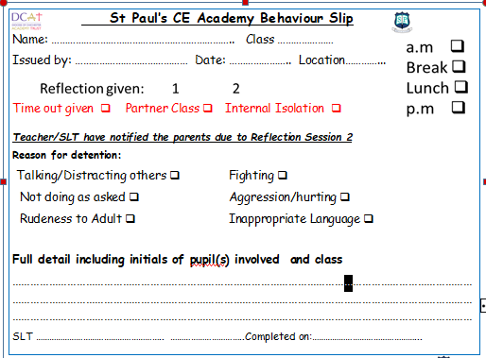

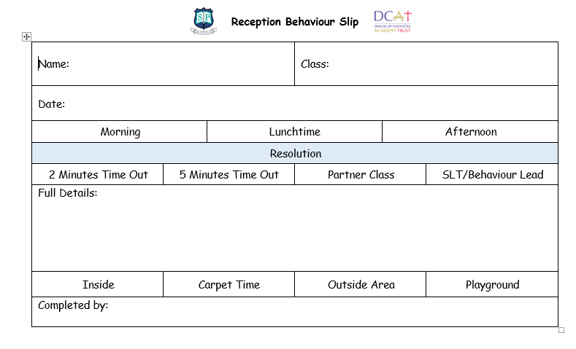

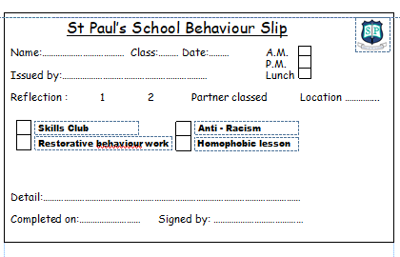

|  |
| --- |
| OUTSTANDING |
| WORKING HARD |
| READY TO LEARN |
| WARNING |
| THINK ABOUT IT! |
| CONSEQUENCE |
| TEACHER CHOICE |

**BEHAVIOUR RESPONSIBILITIES**

**Partner Class**

* Teacher to complete behaviour slip and forward to the front office to put onto Arbor
* Add to ABC if they have one.

**External Exclusion – Decision made by Co-Headteachers**

**Inform Mrs Rodriques**

* Inform parent, arrange reintegration meeting and who will attend.
* Update class teacher
* Inform Mrs Wallbank to ensure correct attendance code.
* Send EXNO and update Arbor.
* Inform Mrs Webber
* Make sure ABC is updated.
* Update risk assessment if needed.
* Complete pupil voice.
* Complete part time timetable paperwork if appropriate.

**Internal Exclusion – Decision made by SLT**

**Inform Mrs Webber who will:**

* Inform parents and arrange a meeting if needed.
* Record any conversations in events.
* Update class teacher and request appropriate amount of work.
* Inform H Wallbank to ensure correct attendance code.
* Update Arbor behaviour.
* Make sure ABC is updated
* Update risk assessment if necessary.
* Complete part time timetable paperwork if appropriate.
* Complete pupil voice.

**Behaviour Support calls/walkie – Mrs Webber**

* First incident SW will monitor and record on Arbor
* Subsequent calls SW start ABC in class file and inform teacher.
* SW- all conversations with parent to be recorded on Arbor.

**Break time club referral**

* Referrer to complete spreadsheet in staff only/behaviour/break time skills club referrals.
* Discuss at CHOC