*This strand explores the impact that technology has on health, well-being and lifestyle. It also includes understanding negative behaviours and issues amplified and sustained by online technologies and the strategies for dealing with them.*

**Your child should be able to identify rules that help keep people safe and healthy in and beyond the home when using technology and give some simple examples.**

**Discussion:** Discuss with your child that there are a set of rules that children need to follow in order to be safe online, both at school and at home.

**Ask your child what they already know about keeping safe online and offline.**

* *Children need to be supervised at all times when using technology.*
* *Children should ask for permission to use devices/the internet.*
* *They should always tell a trusted adult if they have seen something that they are unsure of, has upset them or has made them feel uncomfortable.*
* *Children should be taught not to talk to strangers online and offline.*
* *Children should be taught to never give away their personal information both online and offline.*

**Activity 1:**

* Create a poster to help promote online safety at home.
* 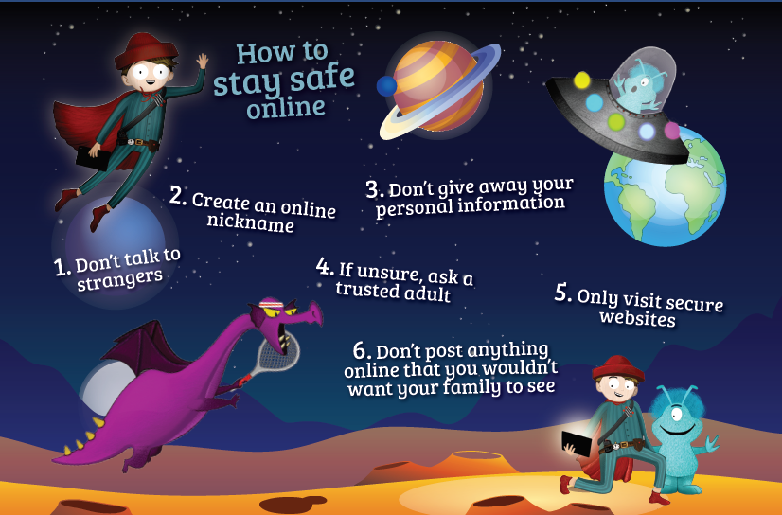Display the poster next to their online device as a visual reminder, when always using the computer.

**Activity 2:**

* Discuss the eight scenarios below. You need to sort them and decide which ones you would use a device ex. you would not use a device when at the cinema but you may use a device when at school for a learning task.
* Write ways in which you would or would not use the device for each scenario.

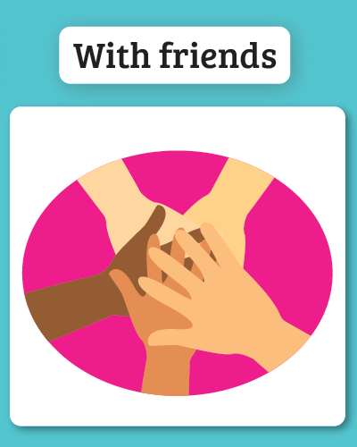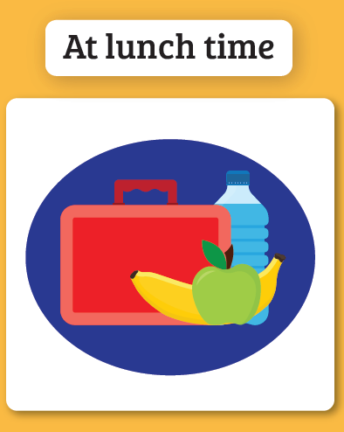

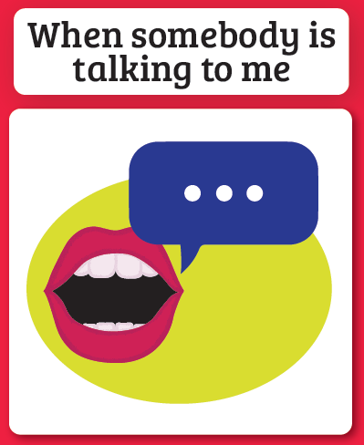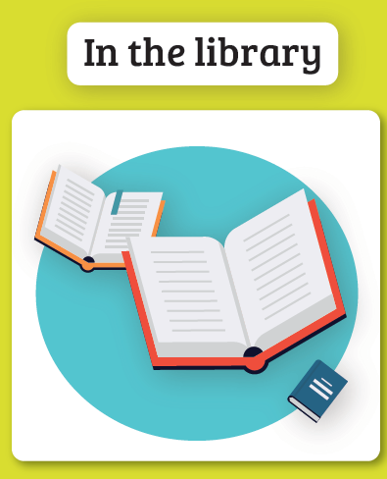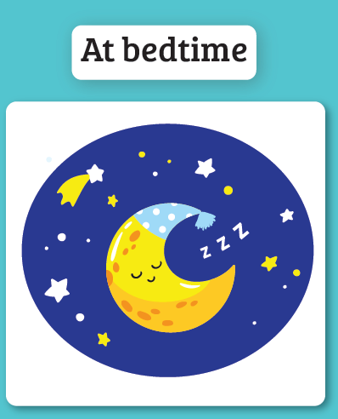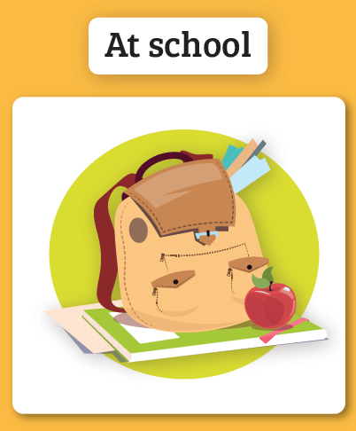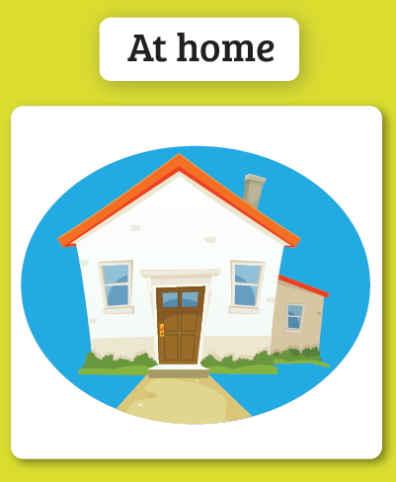

Extension Activity

* Can you think of other environments where you have to use your device in a certain way?
* Add them to your list.