**This term our focus is– Health, Well-being and Lifestyle**

*This strand explores the impact that technology has on health, well-being and lifestyle. It also includes understanding negative behaviours and issues amplified and sustained by online technologies and the strategies for dealing with them.*

**Your child should be able to identify rules that help keep people safe and healthy in and beyond the home when using technology and give some simple examples.**

**Discussion:** Discuss with your child that there are a set of rules that children need to follow in order to be safe online, both at school and at home.

**Ask your child what they already know about keeping safe online and offline.**

* *Children need to be supervised at all times when using technology.*
* *Children should ask for permission to use devices/the internet.*
* *They should always tell a trusted adult if they have seen something that they are unsure of, has upset them or has made them feel uncomfortable.*
* *Children should be taught not to talk to strangers online and offline.*
* *Children should be taught to never give away their personal information both online and offline.*

**Activity:**

* Create a poster to help promote online safety at home.
* Display the poster next to their online device as a visual reminder when always using the computer.

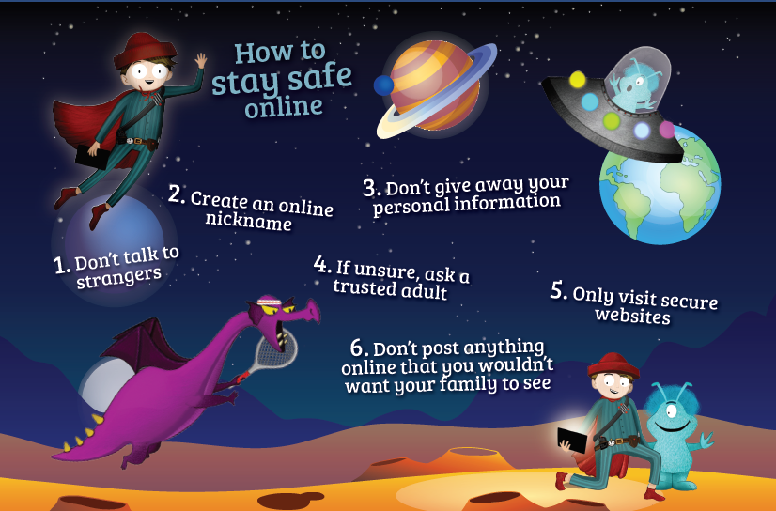

**Extension discussion activity:**

**According to Ofcom’s ‘Children and Parents: Media Use and Attitudes Report’ (2018)**

YouTube is one of the most popular platforms used by young children and 52% ofchildren aged between three and four, go online for nearly 9 hours a week

Bear this inmind when leading your discussions. You may want to discuss what they watch onYouTube, why they watch these videos, and how long they watch these videos for.

Explain that they should be monitored when watching videos on YouTube, and thatthey should always tell a trusted adult if they see anything online that is not right orthey are not sure what they have seen.