Helping Your Child
Learn at Home in
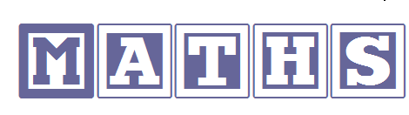

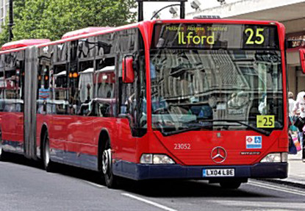
In the street
- Recognising bus numbers.
- Number plate hunt. Who can find a 7? Add the numbers up.
- Comparing door numbers.
- Counting – how many lampposts on the way to school?


Doing the washing
- Counting in 2s – matching shoes.
- Sorting by colour and size.
- Matching/pairing up socks.
- Find four shoes that are different sizes. Can you put them in order?

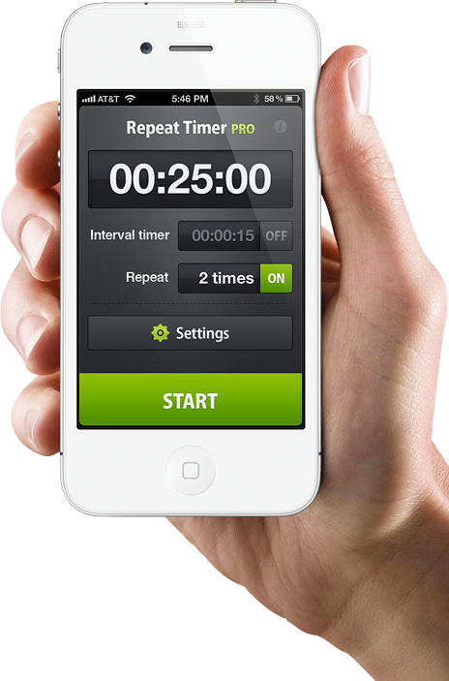
Time
- What day is it yesterday, today, tomorrow?
- Use timers, phones and clocks to measure short periods of time.
- Count down 10/ 20 seconds to get to the table/ into bed etc.
- Recognising numbers on the clock. If you cover a number, what number is missing?

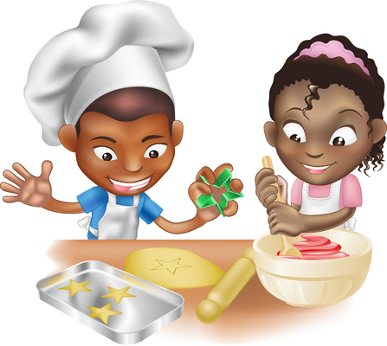
Food!
- Can you cut your toast into 4 pieces? Can you cut it into triangles?
- Setting the table. Counting the right number of plates etc. How many more do we need?
- Can you make shapes/ patterns out of the knives and forks? Can you put them in the right place in the drawers?
- Helping with the cooking by measuring and counting ingredients.
- Setting the timer.
- Positional language at dinner time: what is on the rice, where are the carrots etc?
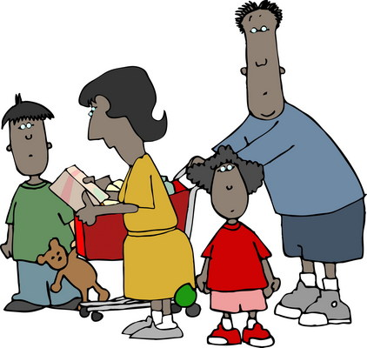
Going shopping
- Reading price tags.
- Counting items into the basket.
- Finding and counting coins.
- Comparing weights – which is heavier?

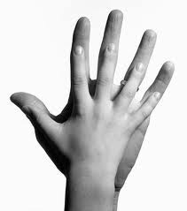
Measuring
- Are you taller than a …?
- Marking height on the wall.
- Cut hand shapes out of paper. How many hands long is the couch? How long is the table? Which is longer?
- Who has the biggest hands in our family?
- How many steps from the gate to the front door?

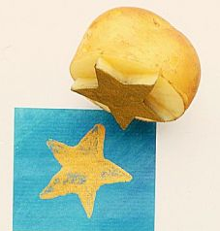
Shapes
- Cut a potato into shapes (circles, triangle etc). Use with paint to make pictures and patterns.
- Cut out shapes from coloured paper/ newspaper and arrange into pictures.
- Shape hunt: Can you find a square in your house (windows etc), a circle …?

Playdough
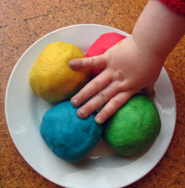
Here’s a simple recipe:
1 cup of plain flour
1 cup of water
1 tablespoon cooking oil
2 teaspoons cream of tartar
Half a cup of salt
Food colouring and essences (optional)
Put all ingredients in a large saucepan and heat slowly, stirring all the time until it forms a ball. Keep it wrapped in clingfilm or in a covered tub to stop it drying out.

Then ….
- Make numbers and shapes.
- Sort shapes into groups, or order by size.
- Make long and short wiggly snakes.

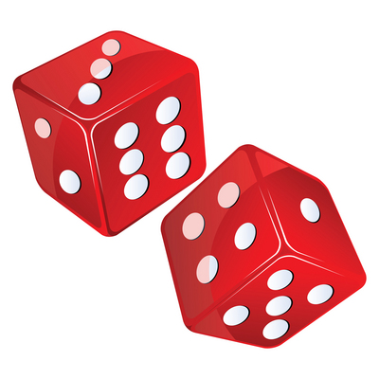
Games
- Putting cards into piles.
- Jigsaws (you can make your own by cutting up a magazine picture).
- Snap (matching pairs) or Happy Families (collect 4 of a kind).
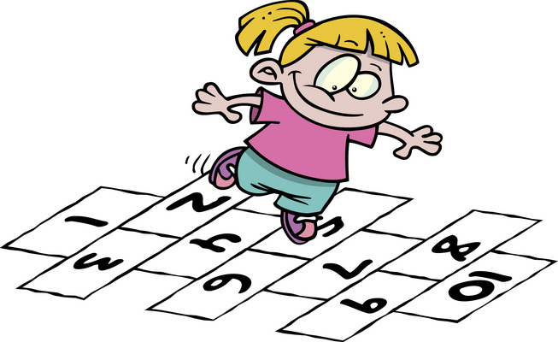
- Snakes and ladders or other simple dice games.
- Adding numbers on two dice.
- Bingo, with numbers or shapes.
- Hopscotch.

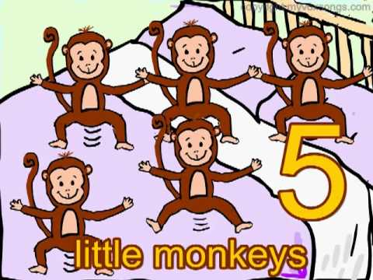
Number rhymes and songs
Eg: 5 little monkeys jumping on the bed
One fell off and bumped his head
Mummy called the doctor and the doctor said
“No more monkeys jumping on the bed!”
4 little monkeys jumping on the bed …

Your child can teach you lots more or try this website which has the words and sings it for you:
http://www.nurseryrhymes4u.com/NURSERY_RHYMES/COUNTING.html


Internet maths games:
www.mathszone.co.uk
http://www.bbc.co.uk/bitesize/ks1/maths/
http://www.familylearning.org.uk/online_math_games.html
www.sesamestreet.org

