Home Learning Pack 2

English

Please read the story of The Ginger Bread Man provided via a PowerPoint document. Discuss the events in the story, what happened at the beginning, middle and end? Next talk about the characters in the story who are they? What do they look like? Can your child describe those using adjectives? On a piece of paper ask your child to draw and label the characters, they can do the same for the settings. These can be done over a couple of sessions you send writing.

Further activities:

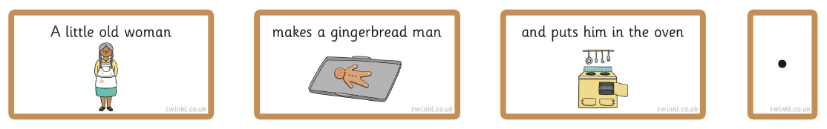Cut out the sentence building cards, ask your child to read and then order the sentences. Explain to your child that there are clues such as a capital letter and a full stop, this should help them understand the order they need to be in.

Story map:

Can your child create a story map and practice retelling the story. The aim of a story map is to use the pictures as clues to retell the story. It does not need to be retold word for word as this gives the children to opportunity to change adjectives and adapt it slightly. 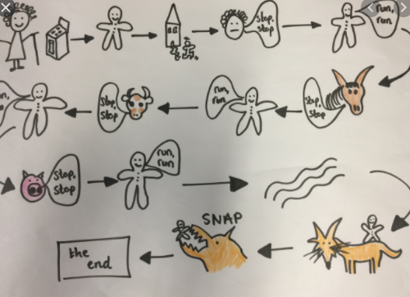

Edit story map:

Can the children change the main character, such as a gingerbread man to a muffin girl? They can retell the story with the new character or write about a new character describing her based on the five senses (see, hear, touch, taste and smell).

Phonics

Please spend 15-20 minutes a day doing reading and phonics. This does not have to be all at once.

In phonics this term we are focusing on revisiting phase 3 and 4 and the use of blending and segmenting the sounds when reading.

Phase 3 sounds – your child should have seen these in reception. Please go over these sounds with your child to see which ones they know. Any sounds they are unsure of please encourage them to write. Can they think of words with those sounds in and have a go at writing them.

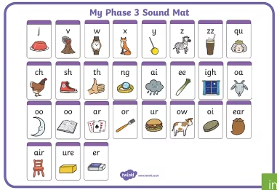

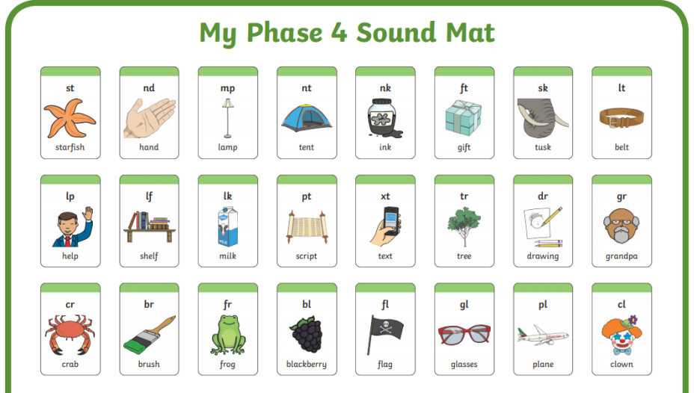Phase 4 focuses on supporting blending sounds when reading, this is to speed up your child’s reading. Alongside the phase 3 recap can your child think of words with these sounds in and have a go at writing them. Can they spot these words in their books at home?

If you do not have a school reading book at home please encourage your child to read a picture book or a range of texts you have available at home and online.

Maths

Our aims for Maths in Term 1 are for the children to:

* Count to **ten**, forwards and backwards, beginning with 0 or 1, or from any given number.
* Count, read and write numbers to **10** in numerals and words.
* Given a number, identify one more or one less.
* Identify and represent numbers using objects and pictorial representations

These activities have been selected to support your child’s learning and to recap some activities they would have done in reception.

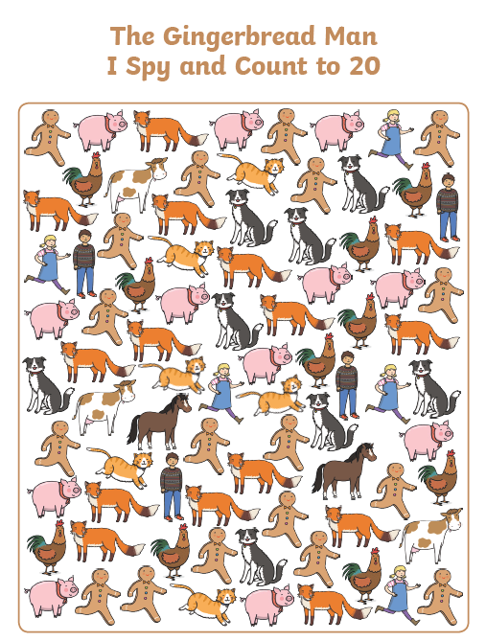

Activity 1: I spy count to 20 using the I Spy sheet your child will need to count the images marking off as they go and putting the total on the next page.

Activity 2: Counting the total, your child needs to count the total number of images and write the total in the circle.

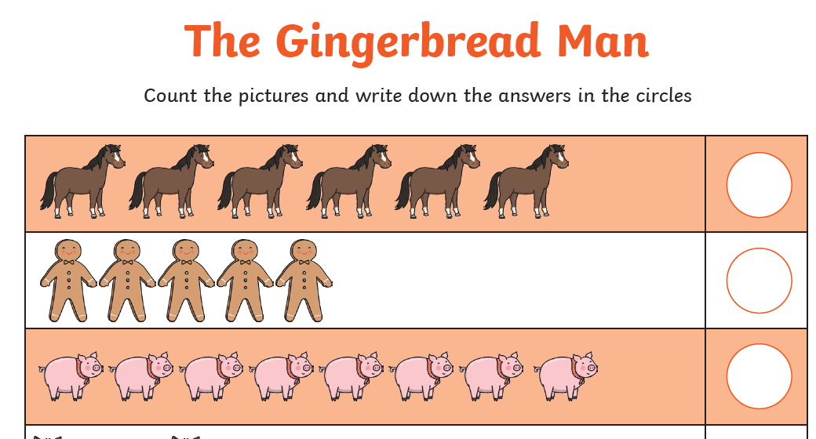

Activity 3: Addition to 10, discuss the meaning of the symbols used (+) add/ to get more (=) the same as/ equal to.

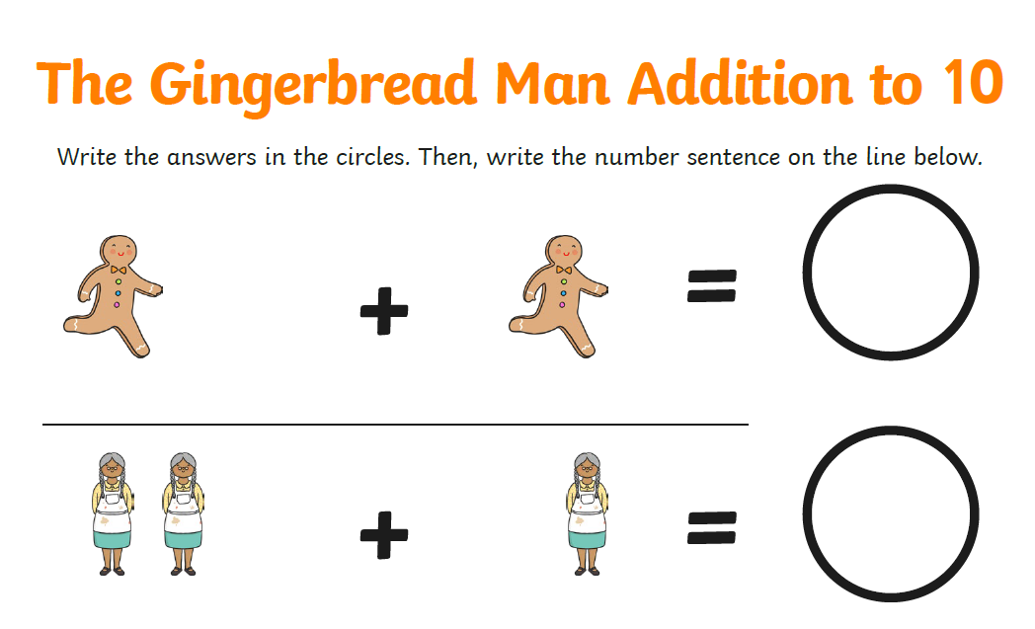

Activity 4: Simple subtraction, discuss the meaning of the symbols (-) to subtract to take away from the larger number. It is important to explain that there are not images on both sides as you need to cross things out as you are taking away. There is an extension sheet of subtraction to 20 if your child has completed this independently. 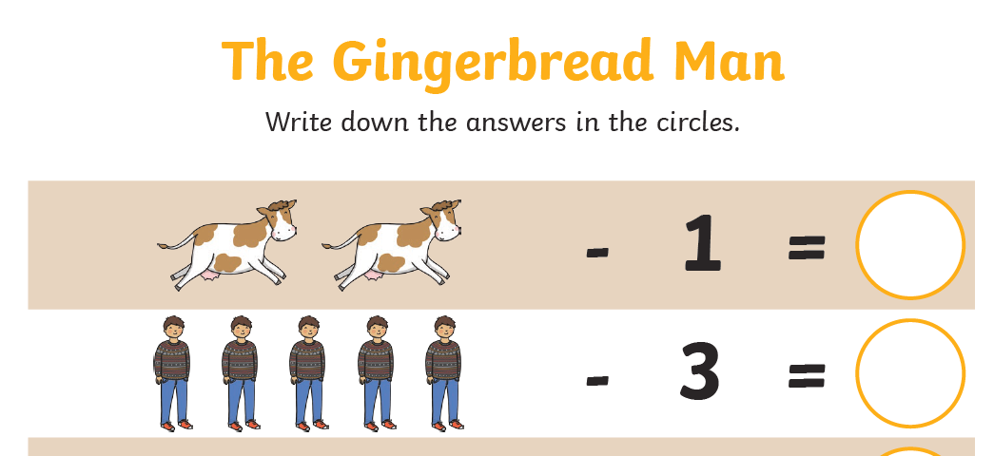

Activity 5: Doubling, explain that having double of something is adding the same amount again. Can your child complete this independently.

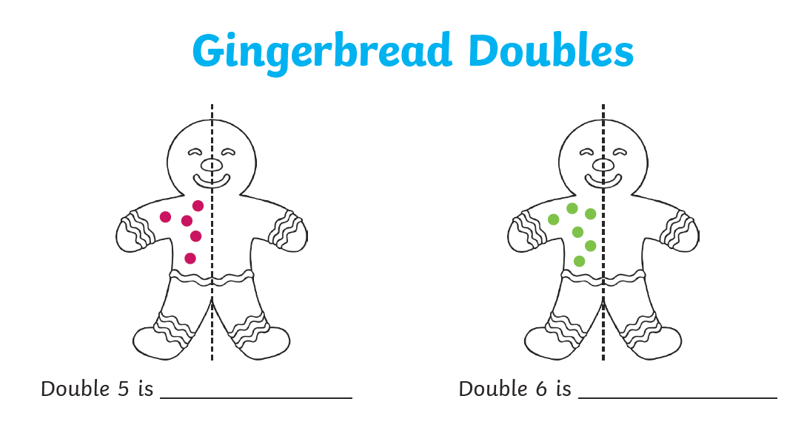

Fine motor

We are encouraging all childrent to use a tripod pencil grip. This is to imporve their handwriting and comfort when writing for longer periods of time.

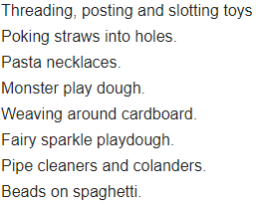Fine motor activities are really important to imporve hand eye co ordination and strength a which together has a huge impact on your child’s handwriting making it a less strenuous task. There are lots of things in the home you can use to support this.

Practising handwriting is also very importnant. Please consentrate on the direction the letters are formed. If your child finds forming letters extremely challenging start with shapes and patterns before moving onto letters.

Patterns 